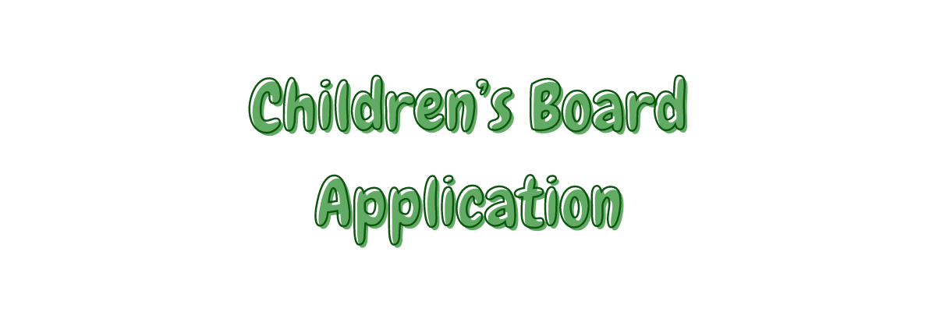
We’re very excited to be able to offer our young session attendees the opportunity to get involved with our brand-new children’s board! We want to be able to allow children to have a say in how we run our charity and what we offer in terms of our services, so we are inviting them to become a part of a board that will help make these decisions. This is a great opportunity for young kids to make some new friends, get involved in some of the fun activities Under The Trees does at sessions, and gain some real experience in decision-making and collaboration. There will also be food!

Initially the board meetings will be more frequent to allow the members to get to know each other and feel comfortable - roughly one session per month - with the aim of eventually reducing meetings to once every two months. Meetings will involve some games and activities, having some food together, and a bit of discussion about the things Under The Trees would like to do, and any ideas the board members have that we could try!

If this sounds like something your child would enjoy, please fill out the following application form and return it to a staff member or email it to volunteers@underthetrees.co.uk.

Child’s Details

Name:
Age:
School:
Interests:
Why they want to join the board:

Best weekday evening(s):

Best time of evening:

Parent Details

Name:
Email:
Phone Number:

Consent Details & Emergency Contact
Please circle your answer/delete as appropriate.
- I give consent for my child to have photographs, video and audio capture taken of them:
YES NO
- I give consent for my child to have photographs, video and audio capture taken of them posted online on social media, newsletters etc.: YES NO
- I consent for any information about my child given in this form to be passed to medical professionals (for example paramedics) in the result of first aid incidents. YES NO

Emergency Contact Name:
Emergency Contact Number:
Emergency Contact Address:

Medical Conditions & Allergies
I would like the following medical conditions and/or allergies to be taken into consideration while my child is a part of the Children’s Board with Under the Trees Ltd. I will make Under the Trees aware of any disabilities for which my child may require adjustments to meeting arrangements by emailing jess@underthetrees.co.uk. I understand that Under the Trees cannot risk assess for any conditions that have not been disclosed.

